

Travlr Getaways Website

CS 465 Project Software Design Document
Version 4.5

Table of Contents

CS 465 Project Software Design Document 1
Table of Contents 2
Document Revision History 2
Executive Summary 3
Design Constraints 3
System Architecture View 3
Component Diagram 3
Sequence Diagram 6
Class Diagram 7
API Endpoints 8
The User Interface 9
Register New User Screen 9
Login Screen 9
Add Screen 9
Added Trip Successfully 10
Edit Screen 11
Edit Trip Successfully 11
Delete Confirmation Screen 12
Delete Trip Successfully 12

Document Revision History

Version | Date | Author | Comments
1.0 | 01/11/2026 | Katlyn Cowley | Updated Executive Summary and Design Constraints
2.0 | 01/15/2026 | Katlyn Cowley | Updated System Architecture Review and TOC
2.1 | 01/16/2026 | Katlyn Cowley | Minor grammar edits and updates.
3.0 | 01/24/2026 | Katlyn Cowley | Added Diagrams and explained APIs.
3.1 | 02/01/2026 | Katlyn Cowley | Incorporated Feedback from Milestone One to update Executive Summary and Design Constraints
4.0 | 02/08/2026 | Katlyn Cowley | Updated the User Interface Section
4.1 | 02/08/2026 | Katlyn Cowley | Updated API Endpoints and TOC
4.2 | 02/12/2026 | Katlyn Cowley | Complete The User Interface Section
4.3 | 02/13/2026 | Katlyn Cowley | Updated API Endpoints
4.4 | 02/14/2026 | Katlyn Cowley | Incorporated Feedback from Milestone Two
4.5 | 02/15/2026 | Katlyn Cowley | Final Edits

Executive Summary

Travlr Getaways is developing a web application to provide customers with an easy way to browse and book travel packages, while allowing administrators from Travlr Getaways to manage trip data efficiently. The application will utilize the MEAN stack (MongoDB, Express.js, Angular, Node.js), which provides a full JavaScript environment that is scalable, maintainable, and capable of handling multiple users. MongoDB serves as the database layer for storing trip, booking, and user data; Express.js and Node.js manage server-side routing and business logic; and Angular delivers a rich single-page application (SPA) experience for administrative users.

Customer-Facing Requirements:
- Display travel packages dynamically using Handlebars (HBS) templates.
- Allow customers to view detailed trip information and navigate the website easily.

Administrator Requirements:
- Provide a single-page application (SPA) to manage trips, update offerings, and monitor bookings.
- Ensure real-time updates between the SPA and the MongoDB backend database for consistent information across the system.

Design Constraints

Design Constraint | Implications for Development
Use of MEAN Stack (MongoDB, Express, Angular, Node.js) | Limits the project to JavaScript-based tools. Developers cannot use other languages or frameworks, which affects available features and how certain tasks are implemented. Ensures consistency across the application.
MongoDB NoSQL Database | Relationships between data (trips, users, bookings) must be handled in the application rather than the database. Requires extra care to maintain accurate and consistent data. Complex queries may be more difficult.
Model–View–Controller (MVC) Architecture | Separates data, interface, and control logic, which improves organization and maintainability. Allows multiple developers to work simultaneously without conflicts. Requires careful planning and structure, which can increase initial development effort.
Single-Page Application (SPA) using Angular | Provides faster and smoother user experience since pages do not reload. Places responsibility on the application to manage navigation and data updates efficiently. Poor implementation can lead to performance issues or inconsistent display of data.

System Architecture View

Component Diagram

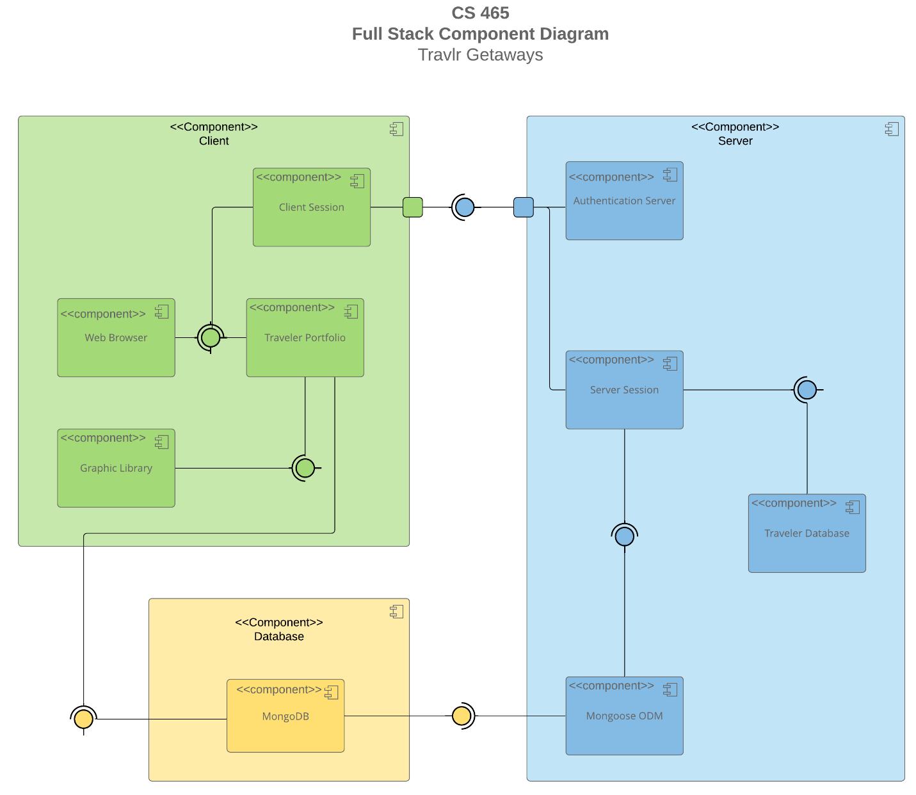

A text version of the component diagram is available: CS 465 Full Stack Component Diagram Text Version.

The Travlr Getaways web application is organized into three main layers: Client, Server, and Database. Each layer has defined responsibilities to make the web application easy to maintain and scalable. This setup keeps presentation, logic, and data separate, so the customer website runs smoothly while the admin interface can manage trips in real time.

Client Components:
- Web Browser: Displays pages and lets customers interact with the site, including trips, rooms, and meals.
- Client Session: Tracks user session data and login status.
- Travlr Portfolio: Stores the customer’s travel information, such as trips and bookings.
- Graphic Library: Stores images and UI elements for the website.

Server Components:
- Authentication Server: Manages login and user verification.
- Server Session: Keeps server-side session data and links client sessions to the database.
- Travlr Database: Stores trip and user information in separate tables.
- Mongoose ODM: Provides structured access to the database for the server.

Database Component:
- MongoDB: Stores all travel, booking, and user data in a flexible, scalable format.

Component Relations:
- The Web Browser interacts with the Travlr Portfolio to display content and manage user activity.
- The Travlr Portfolio uses the Graphic Library for images and communicates with MongoDB (through the server) to get or update data.
- MongoDB connects to the Mongoose ODM, which sends data to a Server Session.
- Server Session coordinates between the Travlr Database and Client Session to keep data consistent.
- The Client Session works with the Authentication Server to verify users and maintain secure access.

Sequence Diagram

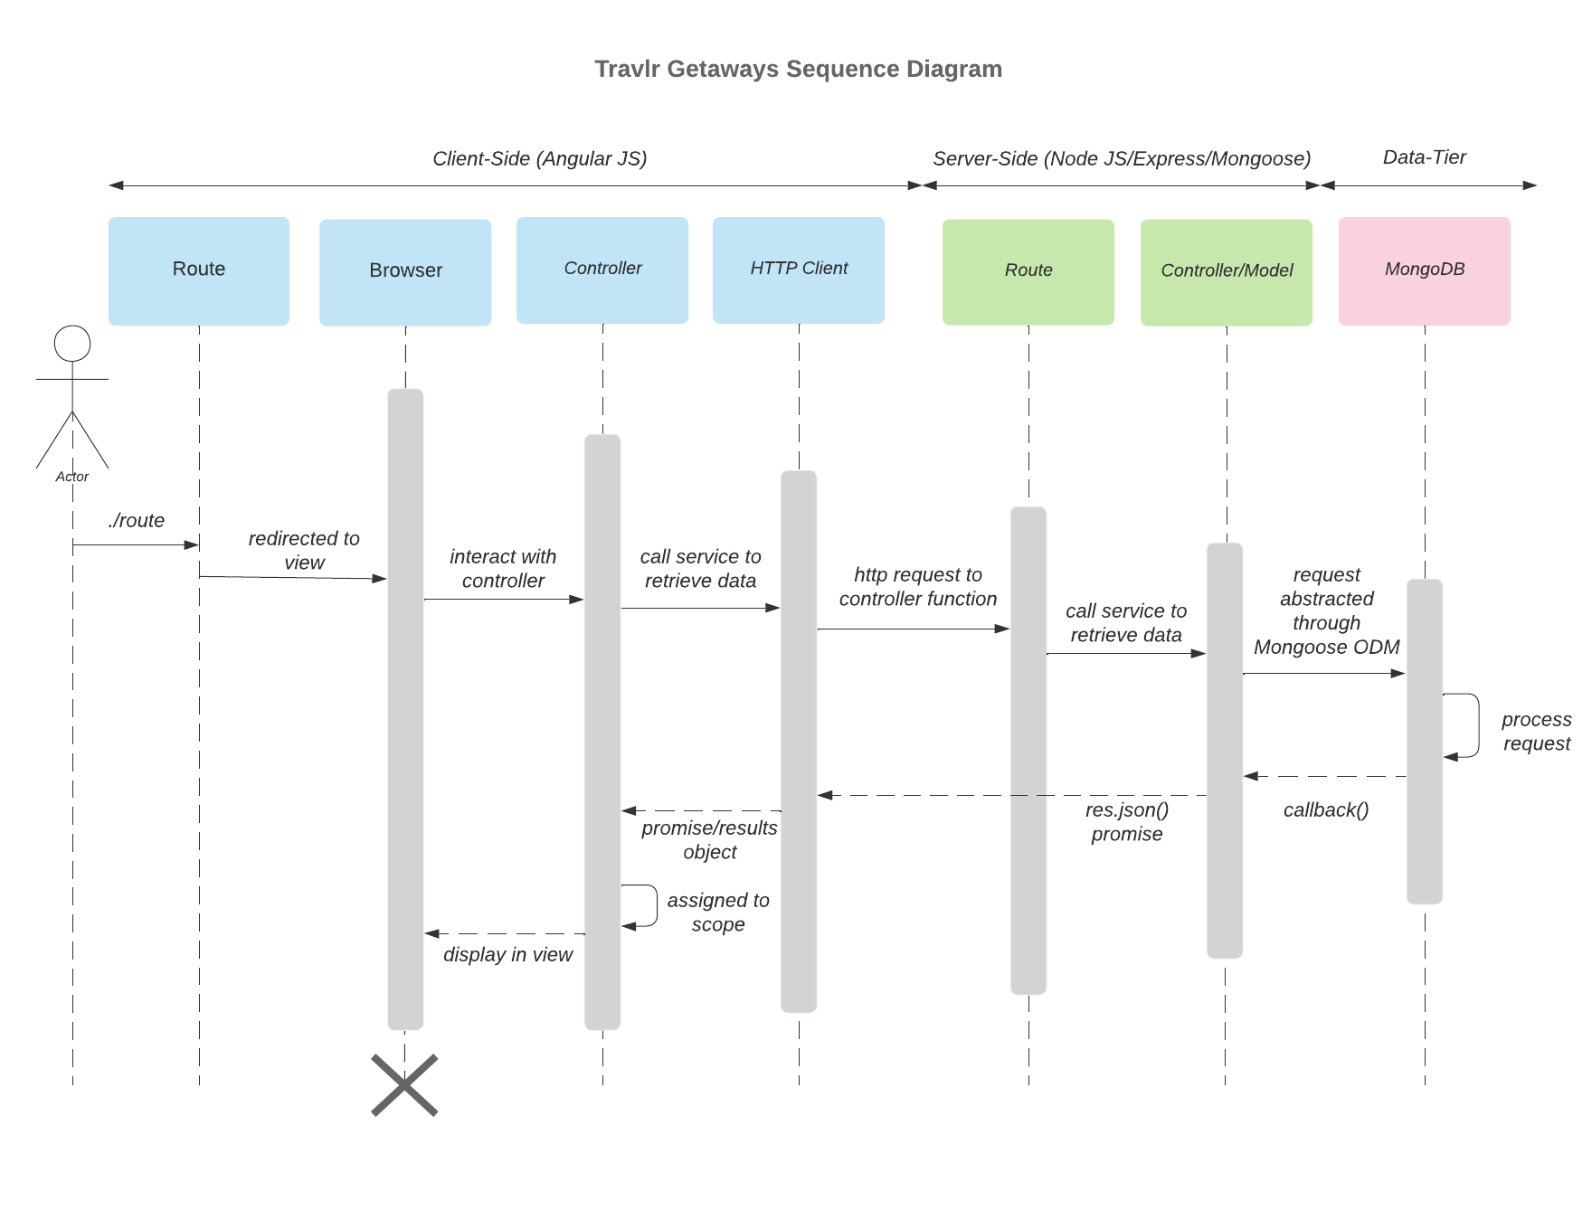
The sequence diagram shows how the Travlr Getaways web application handles user actions across the client, server, and database layers. When a user signs in, the browser sends the login request to the server, which checks credentials in MongoDB and returns a response to the browser. Customers viewing trips send a request to the server, which retrieves trip data from the database and displays it in the browser. Administrators creating, updating, or deleting trips follow a similar process: the browser sends a request, the server updates the database, and the changes are reflected in the view. This flow ensures smooth communication between the front-end, back-end, and database for both customers and administrators.

Class Diagram

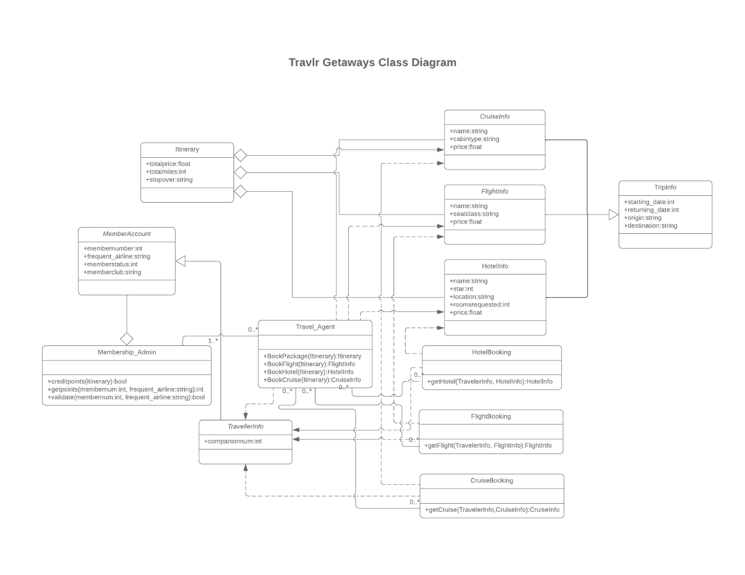
- MemberAccount: Stores login credentials, user roles, and authentication information.
- TravellerInfo: Contains personal details for each customer and links to their trips and bookings.
- TripInfo: Parent class for all types of trips; stores common information like destination, price, and dates.
- FlightInfo: Stores flight-specific details such as airline, departure, and arrival times.
- HotelInfo: Stores hotel-specific details like room type, amenities, and check-in/check-out dates.
- CruiseInfo: Stores cruise-specific details including ship name, cabin type, and itinerary.
- FlightBooking / HotelBooking / CruiseBooking: Connects travelers to their booked trips and tracks reservation details.
- Itinerary: Aggregates multiple trips for a traveler to create a complete travel plan.
- Membership_Admin: Represents administrators who can manage trips, bookings, and user accounts.
- Travel_Agent: Represents staff or agents who manage bookings and assist travelers.

API Endpoints

Method | Purpose | URL | Notes
GET | Retrieve list of trips | /api/trips | Returns all trips
GET | Retrieve single trip | /api/trips/:tripCode | Returns single trip instance, identified by the tripCode passed in the request URL
POST | Adds a single trip | /api/trips | Creates a new trip in the database
PUT | Updates a single trip | /api/trips/:tripCode | Updates a single trip in the database, identified by the tripCode
DELETE | Deletes a single trip | /api/trips/:tripCode | Deletes a single trip from the database, identified by the tripCode
POST | Registers New User | /api/register | Registers a new user (returns login message if user already exists)
POST | Login | /api/login | Logs in user if user exists

The User Interface

Register New User Screen
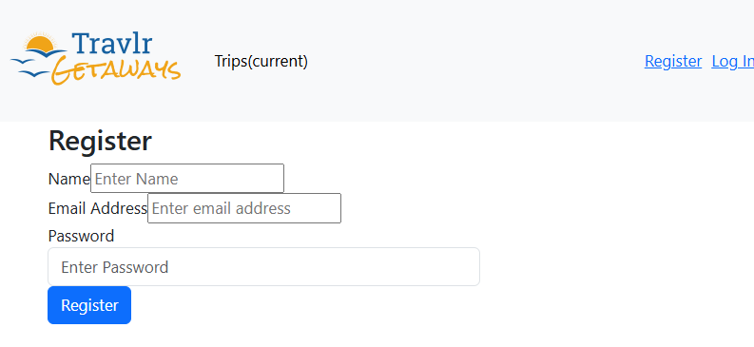

Login Screen
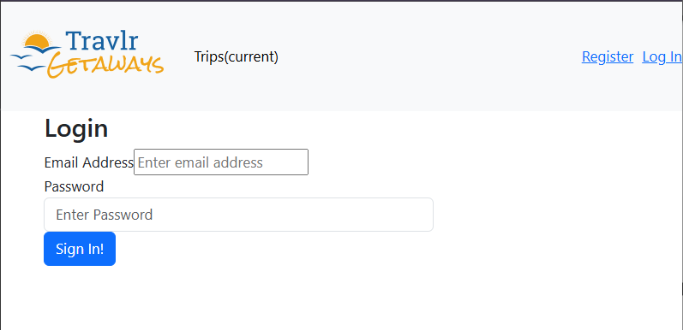

Add Screen
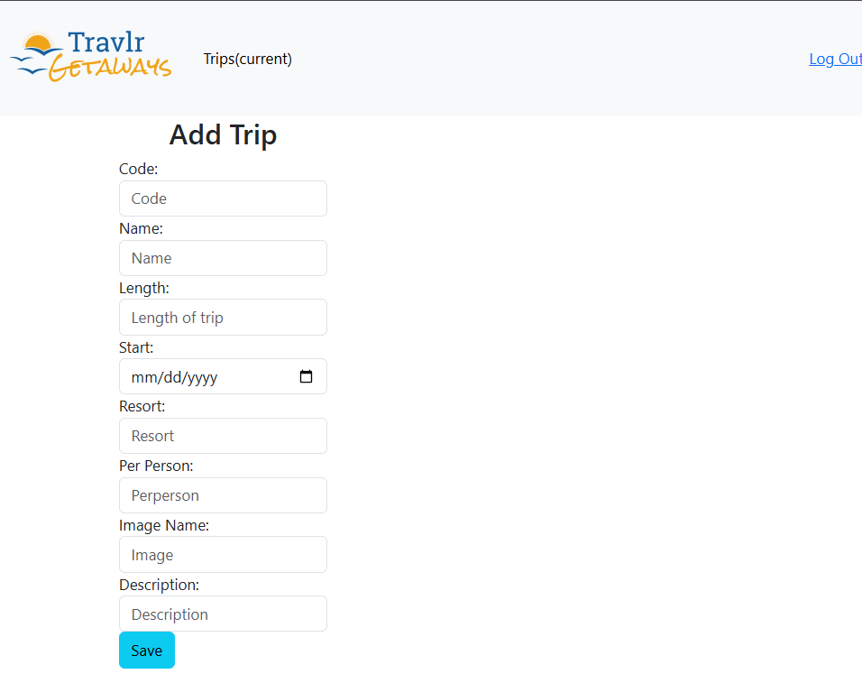

Added Trip Successfully
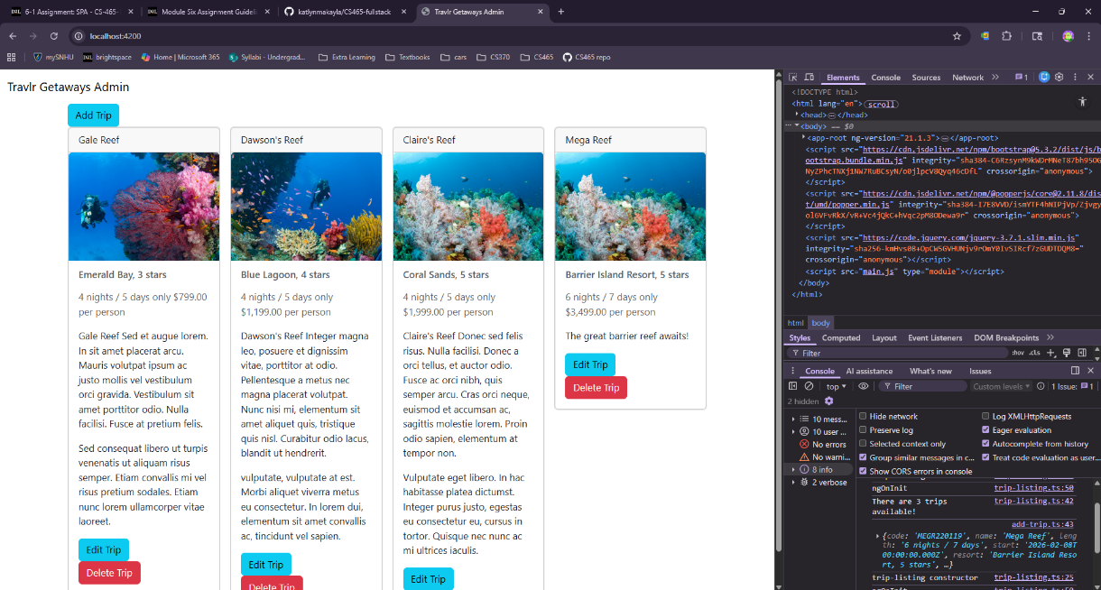

Edit Screen
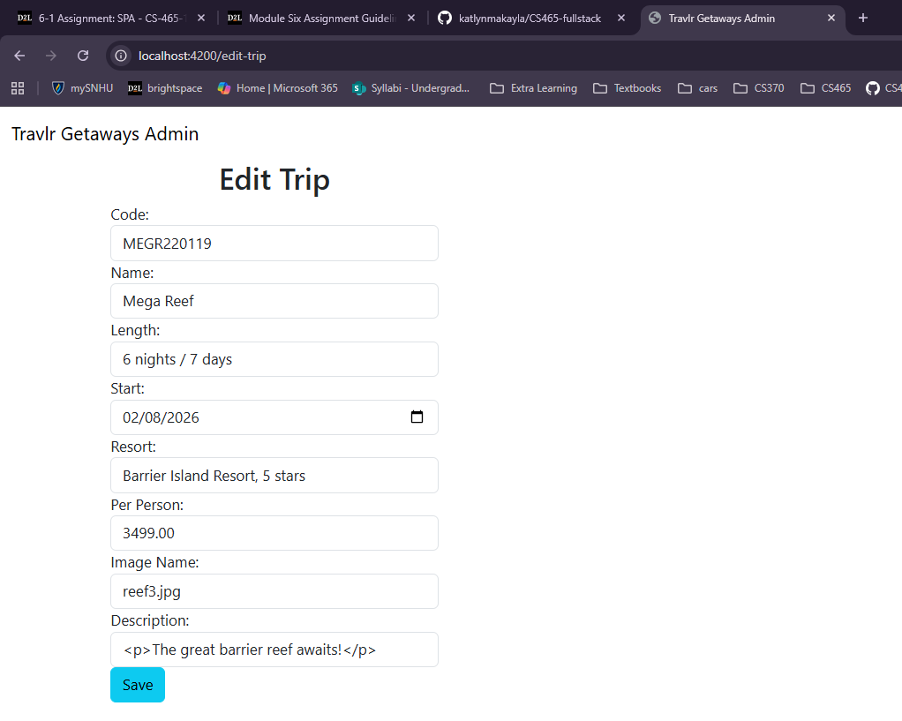

Edit Trip Successfully
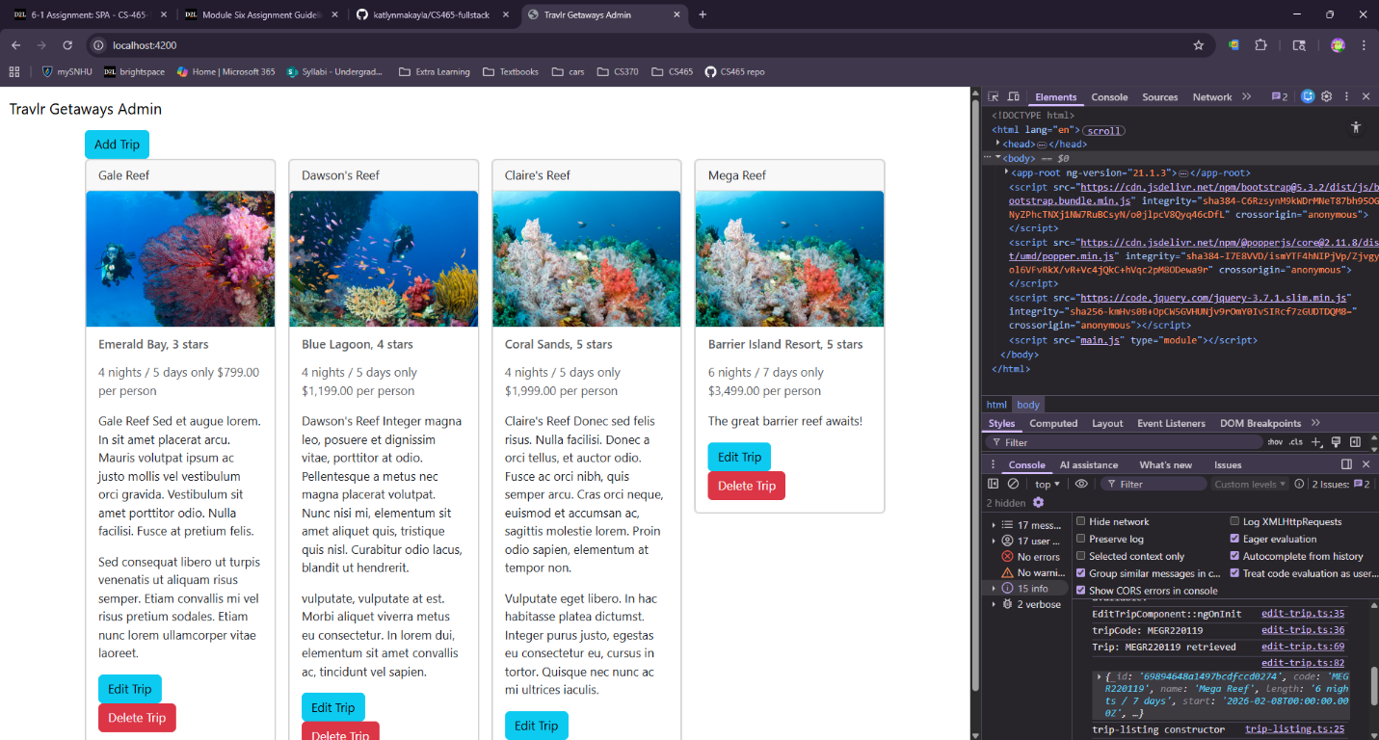

Delete Confirmation Screen
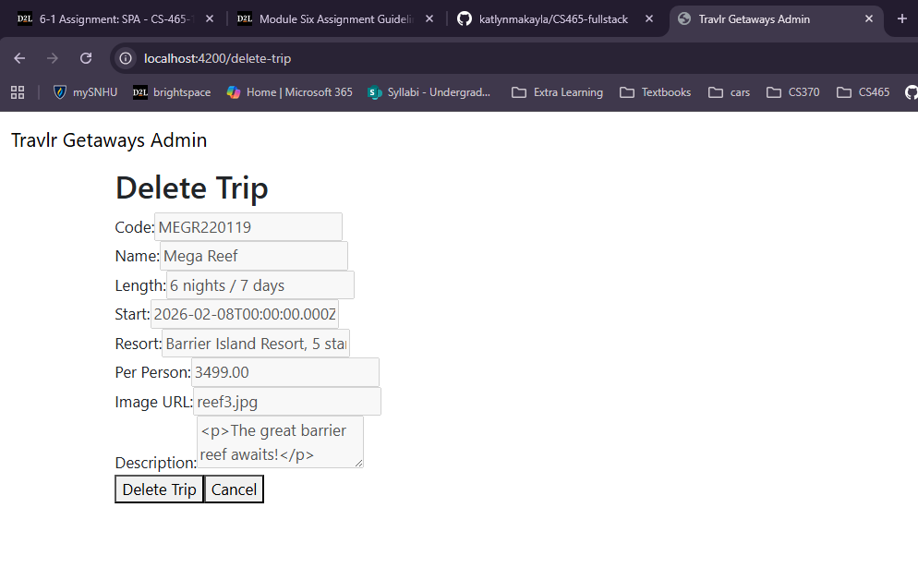

Delete Trip Successfully
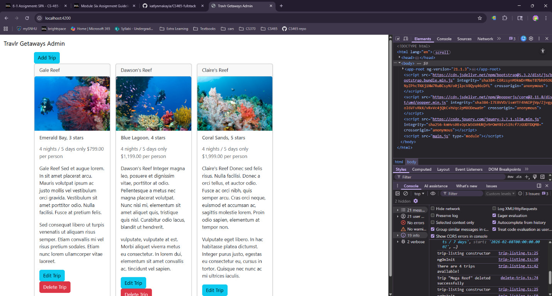

The Travlr Getaways Angular project is organized around components and services, where each component has its own template, style, and logic. This modular structure makes it easy to reuse code and maintain organization as the application grows. In contrast, the Express HTML customer-facing pages are mostly server-rendered and simpler, with all content and logic in one place. While this simplicity can make small pages easier to build initially, it can become difficult to manage and expand when adding new features.

The SPA functionality provided by Angular offers several advantages over a traditional web application. Pages can update dynamically without full reloads, making the user experience faster and smoother. Features like confirmation screens, live updates, and dynamic forms are easier to implement in a SPA than with standard server-rendered pages. The downside is that SPAs are more complex to develop and debug, and they rely heavily on JavaScript being enabled and functioning properly.

To ensure that the SPA communicates correctly with the API, I tested GET, POST, PUT, and DELETE requests in both the browser and Postman. I verified that data changes in the front-end were properly reflected in the MongoDB database and used console logging to visually confirm the details of requests and responses. I made sure to implement Angular’s ChangeDetectorRef to ensure the view updated immediately after the data loaded. For operations like deleting trips, I implemented a confirmation step in the browser to prevent accidental deletions, and tested that trips were not deleted before confirmation. Overall, these tests confirmed that the SPA works correctly with the API and that the interface provides a reliable, interactive experience for both customers and administrators.

